**PHYSICS**

**YEAR 12**

**Unit 3**

**2015**



Name: _______________________________________________________

Teacher: ___________________________________________________

***TIME ALLOWED FOR THIS PAPER***

Reading time before commencing work: Ten minutes

Working time for the paper: Three hours

***MATERIALS REQUIRED/RECOMMENDED FOR THIS PAPER***

**To be provided by the supervisor:**

* This Question/Answer Booklet; ATAR Physics Formulae and Data Booklet

**To be provided by the candidate:**

* Standard items: pens, pencils, eraser or correction fluid, ruler, highlighter.
* Special items: Calculators satisfying the conditions set by the SCSA for this subject.

***IMPORTANT NOTE TO CANDIDATES***

No other items may be taken into the examination room. It is **your** responsibility to ensure that you do not have any unauthorised notes or other items of a non-personal nature in the examination room. If you have any unauthorised material with you, hand it to the supervisor **before** reading any further.

**Structure of this paper**

|  |  |  |  |  |  |
| --- | --- | --- | --- | --- | --- |
| Section | Number of questions available | Number of questions to be answered | Suggested working time  (minutes) | Marks available | Percentage of exam |
| Section One:  Short answer | 10 | 10 | 50 | 54 | 30 |
| Section Two:  Extended answer | 7 | 7 | 90 | 90 | 50 |
| Section Three:  Comprehension  and data analysis | 2 | 2 | 40 | 36 | 20 |
|  |  |  | **Total** | 180 | 100 |

**Instructions to candidates**

1. The rules for the conduct of Western Australian external examinations are detailed in the *Year 12 Information Handbook 2016.* Sitting this examination implies that you agree to abide by these rules.
2. Write answers in this Question/Answer Booklet.
3. When calculating numerical answers, show your working or reasoning clearly. Give final answers to **three** significant figures and include appropriate units where applicable.

When estimating numerical answers, show your working or reasoning clearly. Give final answers to a maximum of **two** significant figures and include appropriate units where applicable.

1. You must be careful to confine your responses to the specific questions asked and follow any instructions that are specific to a particular question.
2. Spare pages are included at the end of this booklet. They can be used for planning your responses and/or as additional space if required to continue an answer.
   * Planning: If you use the spare pages for planning, indicate this clearly.
   * Continuing an answer: If you need to use the space to continue an answer, indicate in the original answer space where the answer is continued, i.e. give the page number. Refer to the question(s) where you are continuing your work.

**Section One: Short response 30% (54 Marks)**

This section has **10** questions. Answer **all** questions. Write your answers in the space provided. Suggested working time for this section is 50 minutes.

**Question 1 4 marks**

Kepler’s 3rd law of planetary motion is:

Derive this formula using at least two other equations from the supplied data sheet. Show ALL steps in your working.

1 mk

1 mk

= (change m1 to M) 1 mk

rearrange gives 1 mk

**Question 2 6 marks**

A spherical, 2.00 kg ball, rests on a plane with a slope of 30.00 as shown in the diagram below. 3 marks

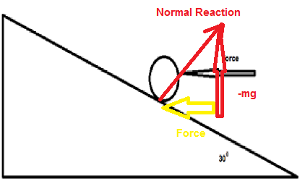1 mk

* 1. Calculate the minimum horizontal force that will prevent the ball moving down the frictionless plane.

tan 300 = = 1 mk

Force = 11.3 N 1 mk

* 1. The horizontal force is removed. Calculate the normal reaction force provided by the plane on the ball. 3 marks

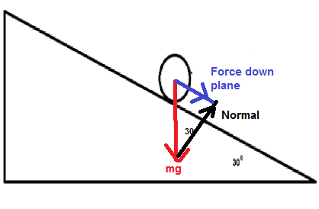1 mk

Normal = cos 300 x mg = 0.8660 x 2 x 9.8 = 17.0 N

1mk 1 mk

**Question 3 8 marks**

A mass spectrometer is used to calculate the mass of charged particles. One such machine is being used to measure the proportion of and nuclei in a beam of particles that have been accelerated to a speed of 5.11 x 106 m s-1. The magnetic field is 5.21 x 10-1 T.

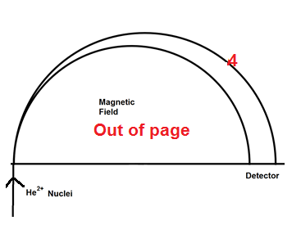

* + 1. Show the direction of the magnetic field on the diagram. 1 mark
    2. Place a “4” on the path followed by the nucleus. 1 mark
    3. Calculate the mass of the given that the radius of its path is

2.01 x 10-1 m 3 marks

1 mark

m = 1 mark

m = 6.56 x 10-27 kg 1 mark

* + 1. Estimate the radius of the path followed by the nucleus.

2 marks

m of He-3 approximately 75% of He-4 1 mark

r α m

r = 0.75 x 2.01 x 10-1 m = 1.5 x 10-1 m 1 mark

**Question 4 7 marks**

The volume of a hydrogen atom is 1.99 x 10-31 m3. Assume the atom is a sphere and the electron travels along its surface.

a. Calculate the force between the proton and the electron:

* + 1. Gravitational 4 marks

1.99 x 10-31 = r = 3.62 x 10-11 m

1 mk 1 mk

F = = = 7.74 x 10-47 N

1 mk 1 mk

* + 1. Electromagnetic 2 marks

= = 1.76 x 10-7 N

1 mk 1 mk

* + 1. Total 1 mark

1.76 x 10-7 N

**Question 5 4 marks**

Juliette (43.2 kg) decided to build a seesaw using a 4.12 m uniform beam. She was accompanied by her friend, Julian (61.2 kg) and her sister, Georgina (21.6 kg). Decide, where the fulcrum could be placed and where each person could then sit in order to create equilibrium.

Need to choose a way that works

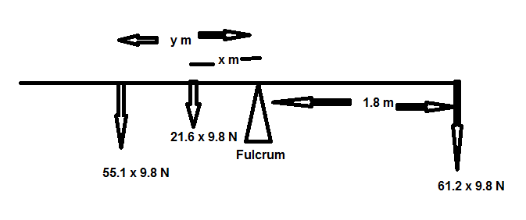1 mk

Eliminate a variable by setting at least 1 1 mk

ξM = 0

61.2 x 9.8 x 1.8 = 21.6 x 9.8 x x + 43.2 x 9.6 x y

110.16 = 21.6 x + 43.2 y divide by 9.8

5.1 = x + 2 y divide by 21.6 1 mk

If x = 2 m, then y = 1.55 m 1 mk

**Question 6 6 marks**

* 1. On the following diagram draw the magnetic fields. Draw at least ten lines.

4 marks



1 mk show lines for repulsion (NN) -1 mk lines touch

1 mk lines attraction (SN) -1 mk lines don’t start on magnets/ball

1 mk lines compressing at steel ball

1 mk lines direction correct

* 1. Draw the electric fields of the following diagram. Draw at least ten lines.

2 marks



1 mk direction

1 mk shape

**Question 7 (6 marks)**

A roller coaster with three passengers has a mass of 9.73 x 102 kg. The participants experience being upside down at the top of the circular track of a “loop the loop” showground ride. The centre of mass of the roller coaster and passengers is 15.3 m from the bottom of the ride. It is travelling at a constant speed of 12.3 m s–1.

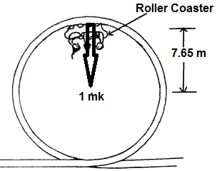

* 1. Calculate the magnitude of the force that the rails at the top of the ride exerts on the coaster plus passengers. (5 marks)

Centripetal Force =

F = N 1 mark

F = 1.92 x 104 N 1 mark

Weight = mg

Wt = 9.73 x 102 x 9.80 N

Wt = 9.54 x 103 N 1 mark

Force of rails on coaster + passengers = Centripetal force – weight 1 mark

Force of rails on coaster + passengers = 1.92 x 104 – 9.54 x 103 N

= 9.71 x 103 N 1 mark

* 1. On the diagram draw a vector to indicate the direction of the force of the rail acting on the coaster plus passengers. (1 mark)

**Question 8**

The photographs show a rechargeable electric toothbrush and its plastic base unit charger.

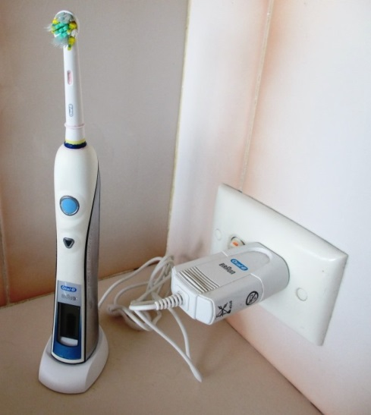

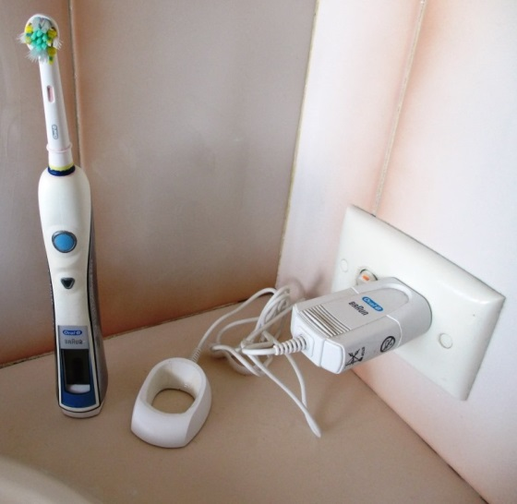

Toothbrush

(3)

Mains socket

Base unit charger

The base unit charger is connected to a mains socket. When the toothbrush is placed into the base unit, as shown in the second photograph, the battery in the toothbrush can be recharged even though there is no direct electrical connection between the toothbrush and the charger. Explain how this possible by reference to appropriate Physics principle.

This is an example of a transformer

A primary coil in the base unit is fed with AC electricity which causes a constantly changing magnetic field 🗸

A secondary coil in the brush is placed near to the primary and the changing magnetic field will induce an emf in it (by Faraday’s Law). 🗸 The induced emf can drive a circuit in the brush to charge its battery. 🗸 (or similar)

Aluminium plate

Plastic plate

North Pole

South Pole

North Pole

South Pole

1. When an aluminium plate is dropped through a magnetic field in a vacuum, its rate is descent is less compared to an identically shaped plastic plate. Explain why this is so.

(3)

Formation of Eddy Currents can only occur within a conductor 🗸

A current is established such that the magnetic fields formed by the Eddy Currents oppose the change in flux that caused them. 🗸

This leads to repulsion which slows down the rate of descent. 🗸 Or similar

**Question 15 continued**

Solenoid

**N S**

Light globe

Magnet moving left

1. The diagram shows a magnet being pulled away from a solenoid that is connected to a light globe.
2. Indicate the direction of induced current in the solenoid. Draw an arrow on the diagram and label it ‘current’.

(1)

Q**uestion 10 6 marks**

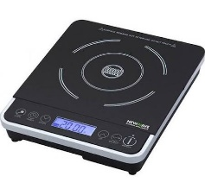The diagram shows a typical hotplate which is common used in households. It can heat water in a saucepan without using flame.

1. Explain how these hotplates can heat water in a saucepan. Include in your answer what material should the saucepan to be made for it to works best. 4 marks

An induction heater consists of an electromagnet driven by a high frequency AC. (1 mk)

This creates eddy currents in the metal of the saucepan. (1 mk)

These currents, due to resistance, create heat. (1 mk)

Steel or iron (1 mk)

Magnetic hysteresis losses in ferromagnetic materials adds to heating

1. Does the hotplate get hot? Explain. 2 marks

The hotplate will get hot (1 mk) if remains in contact with the saucepan and water and conduction occurs. (1 mk)

**Section Two: Problem-solving 50% (90 Marks)**

This section has **seven (7)** questions. You must answer **all** questions. Write your answers in the space provided. Suggested working time for this section is 90 minutes.

**Question 11 12 marks**

Two six-year-old children sit next to each other with their shoulders touching.

* 1. Estimate the gravitational force between them. 3 marks

**Assumptions**:

Mass (m) = 20 F = 1 mk

r = 0.5 m 1 mk F = 1 x 10-7 N 1 mk

* 1. Draw the gravitational field of one of the children (Use at least 6 field lines.)

3 marks

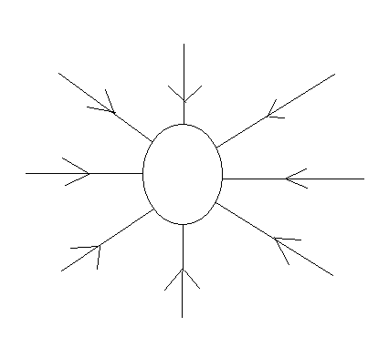

1 mk 6 or more lines start at surface

1 mk lines direction

1 mk no lines touch

* 1. One of these two children climb on top of a shelf that is one metre above the ground.

Estimate the child’s total mechanical energy when they are standing upright on the shelf. 3 marks

**Assumptions**:

Mass (m) = 20 5 kg EK = 0 1 mk

EP = mgh

Centre of Mass = 0.6 m 1 mk Ep = 20 x 9.8 x 1.6 J

EP = 3 x 102 J = EM 1 mk

* 1. One of the children in Question 2 steps of the shelf. When their centre of mass is 0.700 m above the ground estimate their velocity and kinetic energy.

3 marks

EP = mgh = 20 x 9.8 x 0.7 = 1.4 x 102 J 1 mk

EK = x 102 J = 2 (1.8) x 102 J 1 mk

v = 4 m s-1 1 mk

**Question 12 15 marks**

The Perth Wildcats basketball team is two points down and Nat Jawai has the ball in centre court. He puts up the shot and scores.

1. In the space below draw a diagram of the ball showing the force/s acting on it whilst in flight. Assume no air resistance. (2 marks)

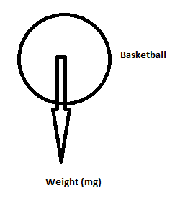

2 mks for just 1 force, 1 off for each additional arrow added

1. He propels the ball at an angle to the horizontal of 42.50. What is the initial speed of the ball? 6 marks

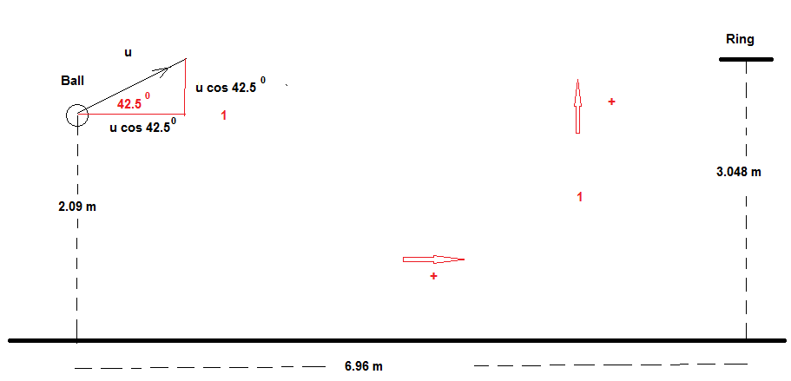

**Horizontal Vertical**

sh = 6.96 m sv = (3.048 – 2.09) m = 0.958 m

uh = u cos 42.50 m s-1 uv = u sin 42.50 m s-1

ah = 0 av = -9.80 m s-2

th = T s tv = T s

3 mks for all info, diagram plus defining directions

(1 mk)

0.958 = u sin A x + 2 (1 mk)

0.958 = tan 42.5 x 6.96 + 2

0.958 = 6.38 -

u2 = 437/(6.38-0.958) = 80.6

u = 8.98 m s-1 (1 mk)

1. Calculate the velocity as it passes through the ring in order to score the three points to win the game? . (7 marks)

uh = u cos 42.5 = 6.61 m s-1 = vh (1 mk) uv = u sin 42.5 = 6.06 m s-1 (1 mk)

v2 = u2 + 2as

v2 = 6.062 + 2 (-9.8) 0.958

v2= 18.0 v = 4.24 m s-1 (1 mk)

Use -4.24 m s-1 as is going down (1 mk)

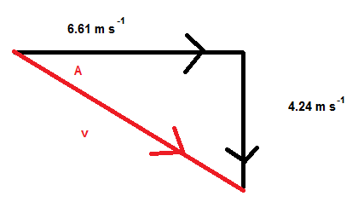1 mk

v2 = 6.612 + 4.242 tan A =

v = 7.86 m s-1 (1 mk) A = 32.70 (1 mk)

1. On the diagram below draw the path of the ball with and without air resistance. Assume that the basketball is launched with the same initial velocity. (2 marks)

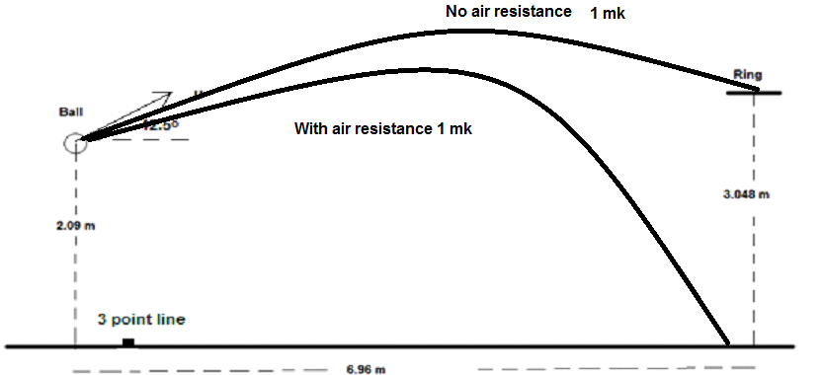

**Question 13 11 marks**

At the centre of the Milky Way is a black hole known as Sagittarius A*. It has a mass equivalent to 4.31 billion Suns. It is 26 500 light years from the Sun.

1. Calculate the gravitational force between the black hole and the Sun.

3 marks

(2 mks)

F = 1.81 x 1019 N (1 mk)

1. Using this force (from part a), to calculate the orbital speed of the Sun around the black hole. (3 marks)

1.81 x 1019 = (2 mks)

v = 4.78 x 104 m s-1 (1 mk)

1. The Sun moves around the black hole (assume circular orbit) with a speed of 2.20 x 102 km s-1. Calculate the centripetal force involved in creating this orbit.

2 marks

2.20 x 10 2 km s-1 is 2.20 x 105 m s-1

(1 mk)

F = 3.84 x 1020 N (1 mk)

1. Compare the values of part b) and c). Explain why they are different. (3 marks)

The second force is ~20x greater than the first, possibly because: (1 mk)

1. Mass from rest of Milky Way contributes to force
2. Dark matter
3. Error in estimates (mass of Sagittarius A*)
4. Error in estimates (distance between objects) (2 mks for any two or other possibilities)

**Question 14 19 marks**

A yacht is moored in a marina being prepared for the Sydney to Hobart race. The uniform boom is 1.50 m above the deck and the uniform cable is attached 1.20 m from the end of the boom. A 50.0 kg weight is attached at the free end of the boom to prevent sudden movement.

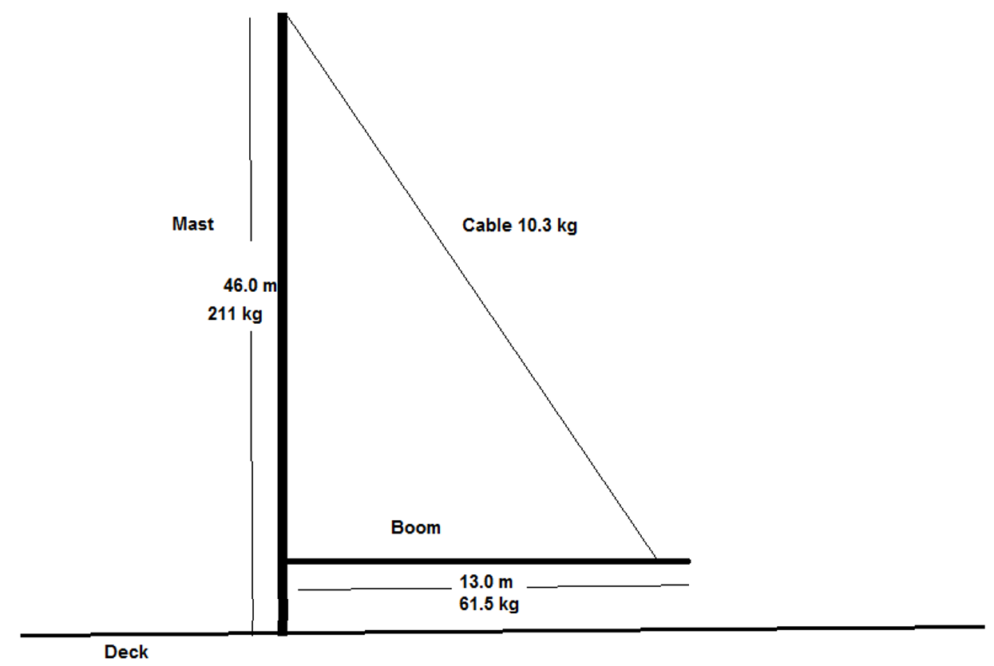

* 1. Draw a free body diagram of the boom showing all forces acting on it.

4 marks

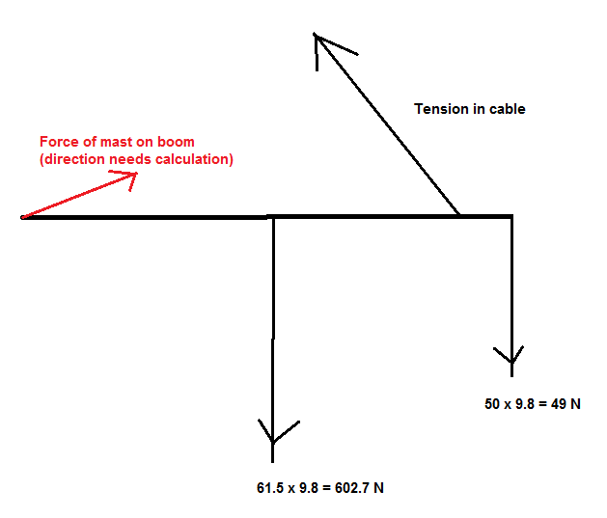

1 mk for each force correct

* 1. Calculate the tension in the cable. 5 marks

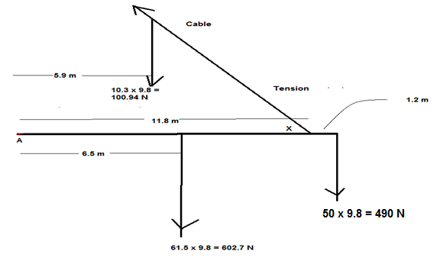

1 mk each for diagram, forces & distances

Calculate X: tan X = X = 75.10 1 mk

Take moments about A (CW +)

0 = 490 x 13 + 602.7 x 6.5 + 100.94 x 5.9 – T sin 75.10 11.8 2 mks

T = 954 N 1 mk

* 1. Calculate the force exerted by the mast on the boom. 5 marks

Vertical Forces (down +)

FV = 100.94 + 602.7 + 490 – 954 sin 75.10 = 271 N (1 mk)

Horizontal Forces (left +)

FH = 954 cos 75.10 = 245 N (1 mk)

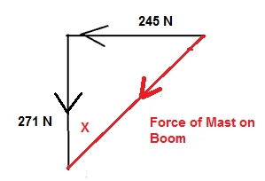1 mk

Force of mast on boom = (2452 + 2712)0.5 = 365 N (1 mk)

X = tan-1 = 42.10 (1 mk)

* 1. Is there any benefit if the cable attachment to the boom is shorter, i.e. less than 13 m? (1 mark)

Shorter length smaller tension in the cable.

**Question 15 17 marks**

AC and DC generators are important technological devices.

1. Using labelled diagram/s illustrate how an AC generator creates an AC voltage.

5 marks

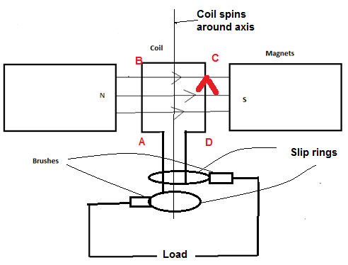2 mks

Coil is spun in magnetic field, produces emf 1 mk

If spins CW (CD out of page) current always up right hand side, in current orientation current enters via top slip ring 1 mk

When AB on right current enters through bottom slip ring 1 mk

Hence current changes direction (AC)

1. At which stage of the cycle is maximum emf generated. Explain. 4 marks

When coil is parallel with field OR when no flux is contained in area of coil. 1 mk

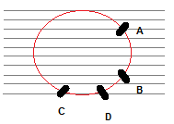1 mk

Size of emf is determined rate of change of flux 1mk

It takes approximately the same time for coil to travel AB as CD, change in flux much greater AB 1 mk

1. Explain the difference in design necessary to change the AC generator to a DC generator. Use diagrams. 5 marks

Change the slip rings to split ring commutators 1 mk

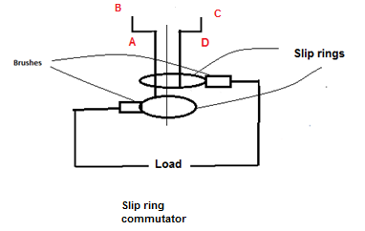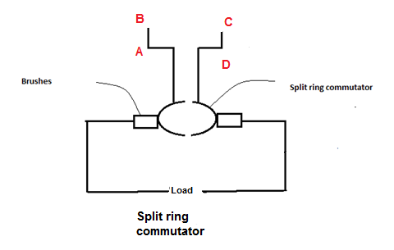2 mks

Brush always connected to one side Split ring connected to CD is in contact with

eg top slip ring/brush always connected right half but quarter turn from current position

to CD 1 mk will be making contact with left brush 1 mk

AC DC

1. The equation

is used to calculate the maximum emf created in an AC generator. Explain, using appropriate diagrams: what is the importance of in this equation.

3 marks

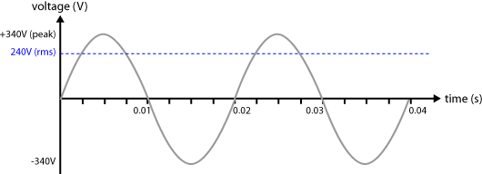2 mks

Need to show correct proportions. Can be other voltages. Need a label for peak and rms (don’t need values provide correct proportions)

is the factor that is equal to the value of the direct voltage that would produce the same power dissipation across a resistor. 1 mk

**Question 16 14 marks**

Two parallel charged plates are set up as in the diagram below.

1. Draw the electric field between the plates 3 marks

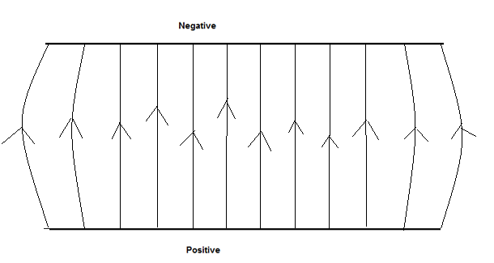

1 mk for field up

1 mk for equal distance between lines

1 mk for bowed ends

1. A proton is fired, with a velocity of 8.67 x 107 m s-1, into the space between the 0.500 m long plates as shown below. The plates are 20.0 mm apart and the potential difference between the plates is 3.00 x 103 V.

The experiment is placed vertically to the ground and the proton is effected by gravity.

Calculate the total force acting on the proton as it travels between the plates.

(4 marks)

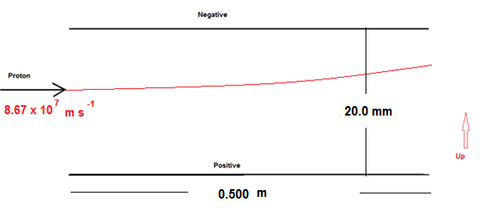1 mk Gravitational = mg = 1.67 x 10-27 x 9.80 N = 1.64 x10-26 N down 1 mk

Electric Field force = = = 2.4 x 10-14 N up 1 mk

Total force up = 2.40 x 10-14 N up 1 mk

1. Calculate the velocity with which the proton leaves the gap between the pates. 5 marks

a = = = 1.44 x 1013 m s-2

**Vertical**

t = = 5.77 x 10-9 s

v = u + at = 0 + 1.44 x 1013 x 5.77 x 10-9 = 8.31 x 104 m s-1

**Horizontal**

v = 8.67 x 107 m s-1 1 mk

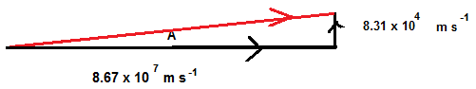

1 mk

Final velocity = [(8.67 x107)2 +(8.31 x104)2]0.5 = 8.67 x 107 m s-1 1 mk

sin-1 A =

A = 0.0549o 1 mk

1. Calculate the vertical displacement of the proton whilst it is between the plates.

2 marks

5.77 x 10-9 s 1 mk

x 10-4 m 1 mk

**Question 17 (5 marks)**

A truck is being driven around a roundabout, of radius 75.0 m, and it rolls over.

1. Explain, referring to centre of mass, why the truck would roll over. (2 marks)

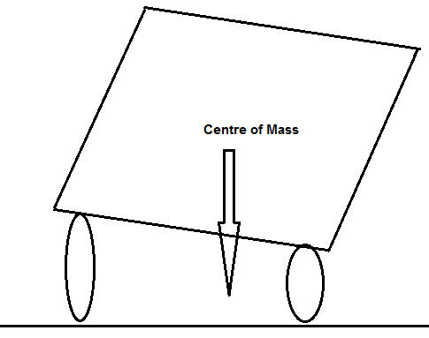 1 mk

If truck leans over so that the vertical line from CoM to the ground is outside of wheelbase it will roll over 1 mk

1. Road engineers bank roads to help prevent such situations occurring. What angle must the road in part a) be banked to allow the driver to travel through the roundabout, safely, at 18.0 m s-1. At the safe speed the truck corners without relying on friction between the wheels and the road. (3 marks)

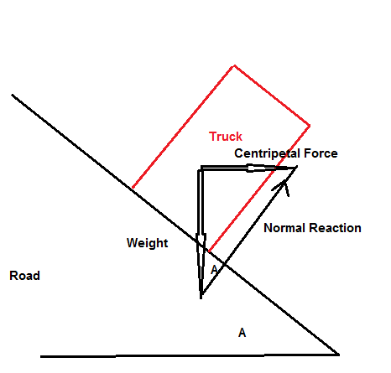 1 mk

tan A = 1 mk

A = 23.8o 1 mk

**Section Three: Comprehension 20% (36 Marks)**

This section contains **two (2)** questions. You must answer both questions. Write your answers in the space provided. Suggested working time for this section is 40 minutes.

**Question 18 Circular Motion (18 marks)**

Many everyday examples rely on circular motion. Satellites for weather observations, GPS, communications and monitoring activities is one such group. Some others include spin dryers in washing machines, separating blood samples into its components in a centrifuge and mass spectrometers.

Centrifugal force does not exist in an inertial frame of reference and is generally considered to be a “mythical” or inertial force. In the past it was sometimes defined as the reaction force to the centripetal force. Centrifugal is based on the Latin word which means flight (moving away from centre), centripetal comes from the Latin for seeking (moving towards centre).

A satellite orbiting the Earth in a circular orbit is always falling towards the Earth yet maintains the same altitude.

Rockets are used to place satellites in their respective orbits. Satellites that have orbits parallel to Earth’s equator are generally launched in an easterly direction from the east coast close to the equator.

Geostationary satellites are usually launched in this manner. These satellites are a significant reason that we can receive continuous TV signals from the other side of the world. Pay TV companies also use geosynchronous satellites as well as cable to provide services to their customers. They are also valuable in weather services as each satellite monitors a set part of the Earth’s surface.

An experiment to demonstrate the forces involved in circular motion is set up as follows:

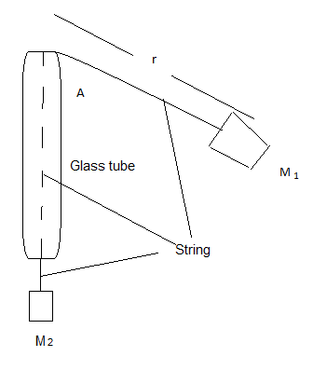

A student holds the glass tube and swings the rubber stopper (M1) in a circle maintaining a constant radius. The force (tension in the string) is provided by the mass (M2). Another student measures the time taken for 25 revolutions.

The following is a set of results for one such experiment.

M1 completes at least 25 circuits.

M1 has a mass of 38.3 g

R is 61.3 cm

|  |  |  |  |  |
| --- | --- | --- | --- | --- |
| Trial | Force of M2  (N) | Time for twenty (25) revolutions  (s) | Period  (s) | Velocity2  (**m2 s-2**) |
| 1 | 0.50 | 34.1 | 1.36 | 8.0 |
| 2 | 1.50 | 19.7 | 0.79 | 23 |
| 3 | 2.50 | 15.3 | 0.61 | 40 |
| 4 | 3.50 | 12.9 | 0.52 | 56 |
| 5 | 4.50 | 11.4 | 0.46 | 71 |
| 6 | 5.50 | 10.3 | 0.41 | 87 |

1. Complete the two incomplete columns. 1 mark
2. Which is the independent variable? 1 mark

Force

1. Plot the data. 3 marks

**TITLE: Force and velocity2 graph**

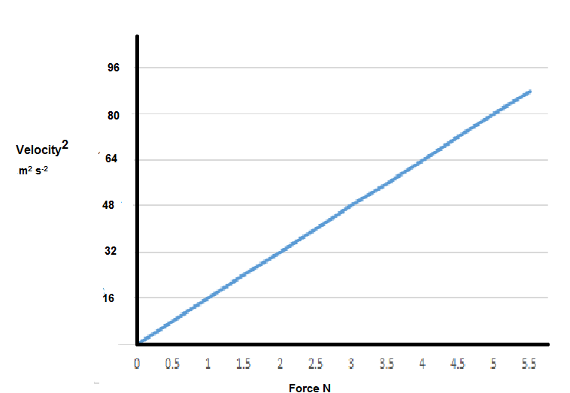

1 mk plots, 1 mk scale, 1 mk units

1. Plot a line of best fit. 1 mark
2. Find the gradient of F α V2. (2 marks)

Gradient = = 0.0625 N s2 m-2= [0.0625 kg m-1] 1 mk magnitude, 1 mk units

1. What is the important information of the gradient? 1 mk

Ratio of length of string to mass of M1 = 0.613/0.0383 = 16

1. No matter how fast you can reasonably make M1 travel it will never have a horizontal string. Why? 1 mark

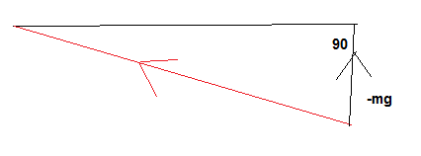1 mk

Must have component to support weight 1 mk

1. A satellite that is constantly falling can maintain a circular path around the Earth at a constant altitude. Use a diagram to help explain why this occurs. 3 marks

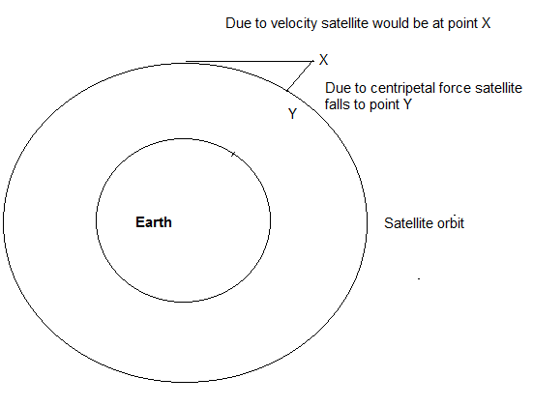 1 mk

But centripetal force is always at right angle to velocity 1 mk

So this is continuous process, when in orbit always falls exact amount as it moves forward (Newton’s First Law) 1 mk

1. Explain why, that when a satellite is in a circular orbit around the Earth the centre of its orbit must be the centre of mass of the Earth. Use diagrams. 2 marks

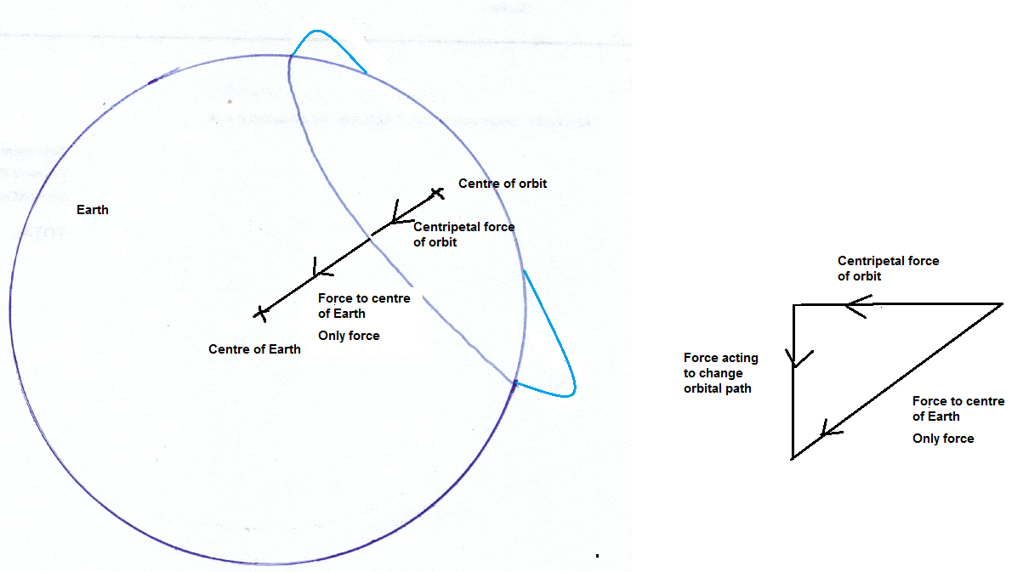

1 mk for each diagram

1. Whilst falling the satellite could be said to be weightless. Explain. 3 marks

The child’s perception of weight is due to the reaction force of the ground. (1 mk) In free fall no reaction force. (1 mk). Can only be weightless if infinite distance from ALL other masses. (1 mk)

**Question 19 AC/DC: Rock Band or Electricity Wars (18 marks)**

Edison and Tesla, two great scientists found themselves on the opposite sides of the debate whether to use DC (Edison) or AC (Tesla).

Edison to prove his point that AC was too dangerous electrocuted and elephant and advocated that AC be used for the electric chair. Further he built 121 DC power stations in the United States of America. The Boulder power station in the Goldfields of Western Australia was originally a DC power station. Unfortunately, users of this power had to be within 2 km of the station.

AC power could be readily converted from low to high voltages and back again so it could be transferred long distances with lower energy losses.

Much of our electronics today use DC power and when the AC is converted to DC about 3% energy is lost in the form of heat. Also LEDs which use DC suffer from flicker which reduces their lives, and solar panels produce DC current which is converted to AC using inverters. DC can now be converted to high voltages relatively easily and voltages for transmission of up to 800 kV have been achieved.

An issue with high voltage is the “skin effect” which means that at high voltages the current travels on the outside of the wire which effectively increases the resistance of the wire. This then requires that more expensive multi-strand wires are required to transmit the power.

Further many places use UPSs (Uninterruptable Power Supplies) which convert AC to DC (batteries) then back to AC and then back to DC to run the electronics.

Should we convert our power supplies to DC which is safer, much of our electronics use DC already and much of the green energy produced is DC and would be more compatible with a DC grid.

On the reverse many of our appliances are AC based and our power stations are all built to provide AC. Converting them would be a huge expense.

The South/West power grid operated by Western Power extends from Kalbarri (600 km North of Perth) to Ravensthorpe (530 km SE of Perth) across to the coast, with an extension to Kalgoorlie.

Synergy is the electricity generator and retailer for the grid. They charge domestic customers 23.36630 c/unit. A unit is a kilowatt hour.

A power station can generate 6.00 x 102 MW of energy at 30.0 kV. This is then sent to a sub-station where the voltage is increased to 3.30 x 102 kV. This is then transported at that voltage over large distances. It then comes to a series of sub-stations that step down the voltage to 33.0 kV, then 11.0 kV, 6.00 kV and finally about 4.00 x 102 V. Each transformer stage loses approximately 1.00% (ie 99% efficient).

The power is distributed from the last sub-station as three phase power down the streets. Most houses opt for one phase (2.40 x 102 V) at a frequency of 50.0 Hz.

Large voltage wires are usually multi-strand aluminium cables surrounding an iron core which provides the tensile strength. The resistance of the wire is 1.02 x 10-4 Ω m-1.

1. Explain why multi-strand wires are used in large voltage power lines.

2 marks

High voltage electricity travels on outside of wire increasing resistance 1 mk

Multi-strands provide more skin volume to carry current 1 mk

1. Calculate the energy lost in transmitting 3.30 x 102 kV AC electricity from the generator to sub-station 1 to a town 151 km away. 7 marks

Power loss in transformer 1.00% is 1/100 x 600 MW = 6.00 MW 1 mk

P = VI = 540 X 106 = 3.30 x 105 x I 1 mk

I = 1.64 x 103 A 1 mk

Ploss = I2R = (1.64 x 103)2 x 151 x 103 x 1.02 x 10-4 W

1 mk 1 mk

Ploss in wires = 41.2 MW 1 mk

Total Power loss = 47.2 MW 1 mk

1. Calculate the loss over a year in possible revenue that Synergy loses because of this loss of energy? 4 marks

1 year = 365.25 x 24 = 8.77 x 103 hours (hr) 1 mk

Energy loss = t x P = 8.77 x 103 hr x 47.2 x 103 kW = 4.14 x 108 kW hr 2 mks

Cost = $4.14 x 108 x 0.2336630 = $96.8 million 1 mk

1. What is the voltage of three phase power in Western Australia? 1 mark
2. Explain the cause of the “flicker” in LEDs. 3 marks

LEDs need to run on DC 1 mk

This results in 50 times every second there is no current (flickers) 1 mk

as the LED (diode) only allows current in one direction 1mk

OR Any other suitable answer

1. Why does DC lose less power in transmission than AC? 1 mark

Resistance in wires is less.